Huff N Puff Cottage April 2023

How it started
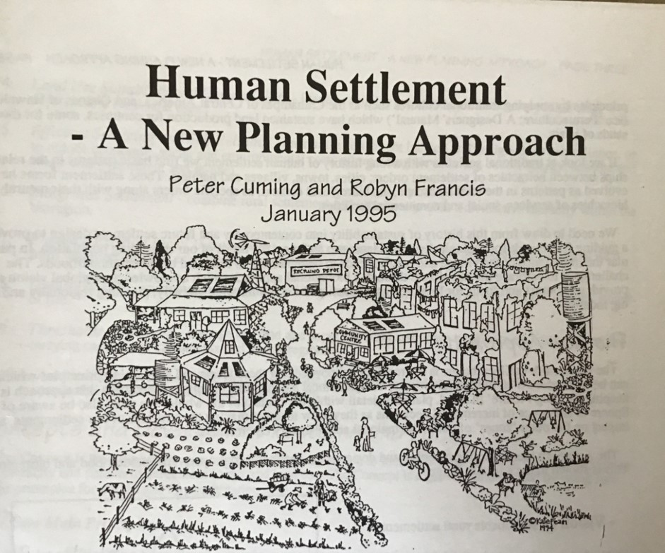

Step 1
- Sept 2002, six community members formed the "Dawdelup Syndicate".
- Nov 2002. The group signed a syndicate agreement (blue book)
- Purchased 5 acre property on Jayes Road "Hazelbrook".
- 6 homes to be built (4 so far)

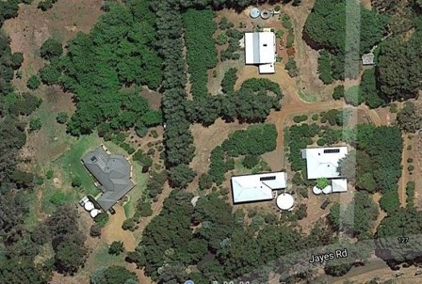
The Process
2003 | Prepared Scheme Amendment (did this ourselves) (3)
Jul 03 | Council consent to advertise.
Aug 03 | Submitted Scheme Amendment to WAPC. “Mature Lifestyle Development” for the over 50’s.
Feb 04 | Council adopts and refers to Minister for approval.
Sept 04 | Last minute change made by DPI - age increased to 55.
Oct 04 | Scheme Amendment approved by WAPC.
 | Now Ok to build homes but we own 1/6th of each other’s homes………….no individual titles.

And then we had to strata title
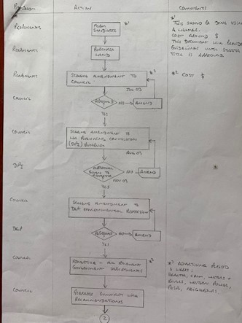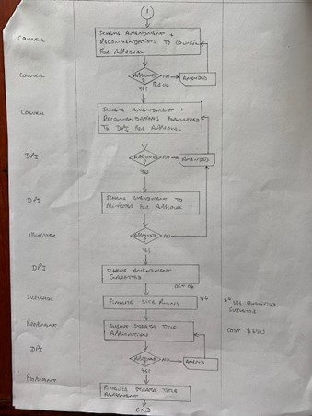

Jan 05 | Submitted Strata Title application to WAPC (did it ourselves)
2005-2006 | Built four homes
Jan 06 | State Administrative Tribunal (4)
June 2008 | Strata Title approved. (5)
Now | Annual General Meetings (See folder)  When a new person buys, we have to provide Strata package. (6)

Dawdelup planning meeting
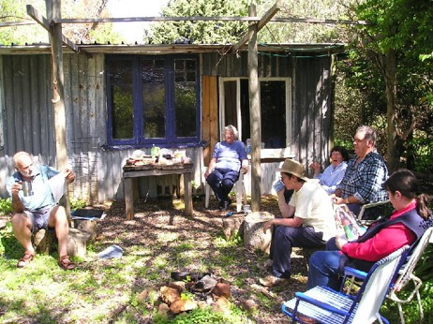

- Cluster Developments
  - 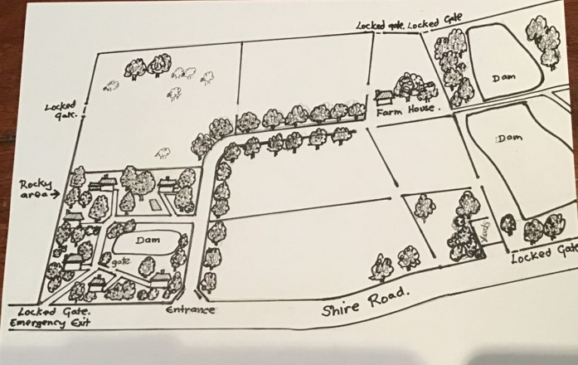
  - Make it easy.
  - Use poor agricultural land.
  - Included in Shire of Donnybrook-Balingup Rural Strategy.
  - Currently with WA Planning Commission.
  - Next step community consultation

HUFF ‘N PUFF COTTAGE
- The dream begins with 220 strawbales
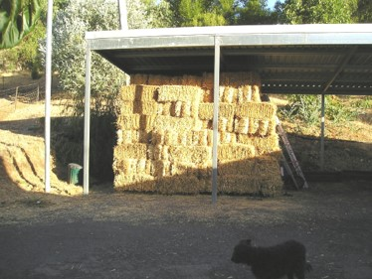
April 2005 – the pad goes down
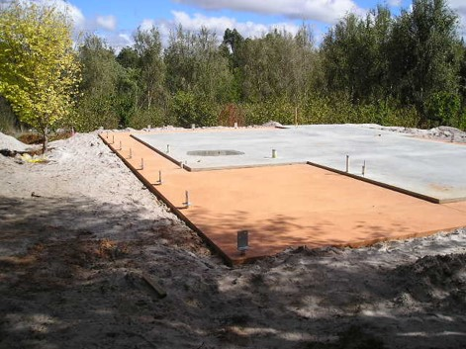
28 May 2005 – the structure takes shape.
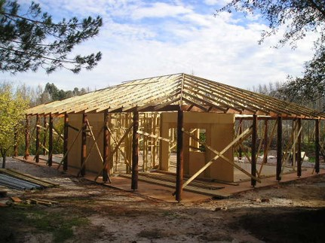
13 June 05 – the strawbales arrive on site
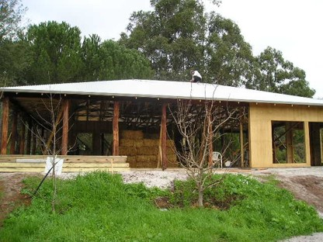
The first bale goes down
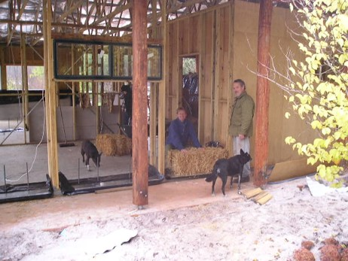
Inside lounge
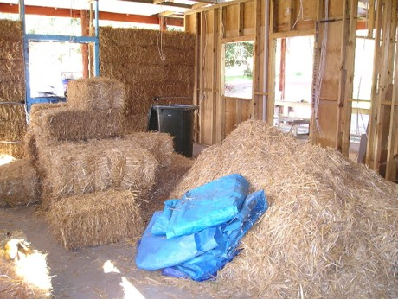
June 2005 – inside the lounge
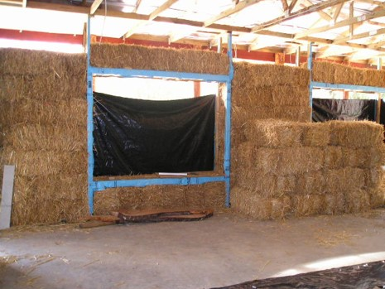
26 June 05 - the walls are up
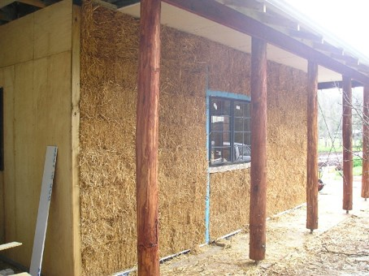
And whipper snippered
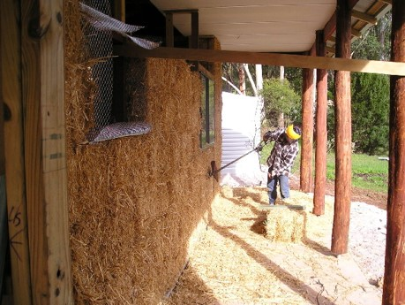
And chicken mesh applied
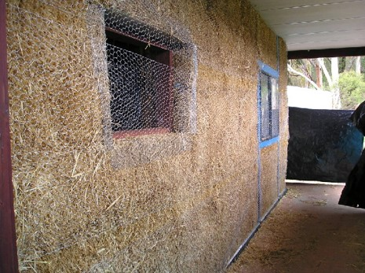
1st coat render
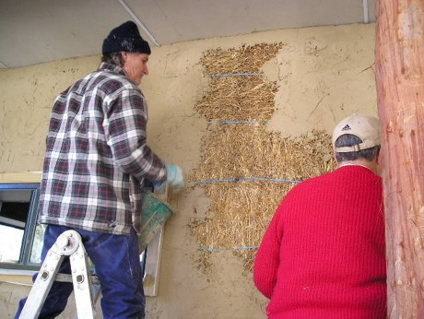
Three coats render applied
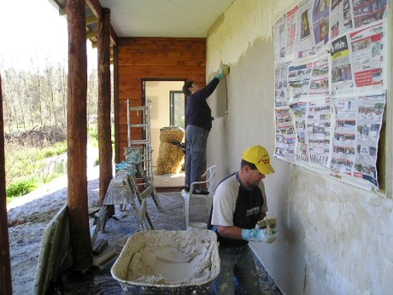
8 Aug 05 – final coat of render
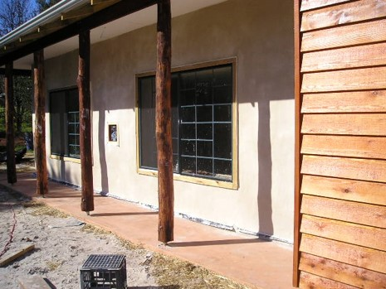
September 2005 – I’m in!
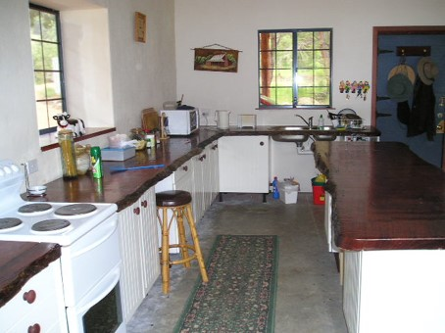
December 2005
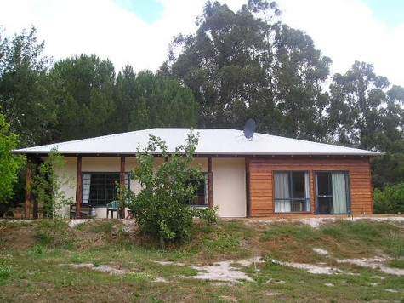
January 2006
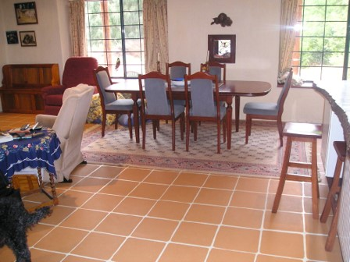
The window view
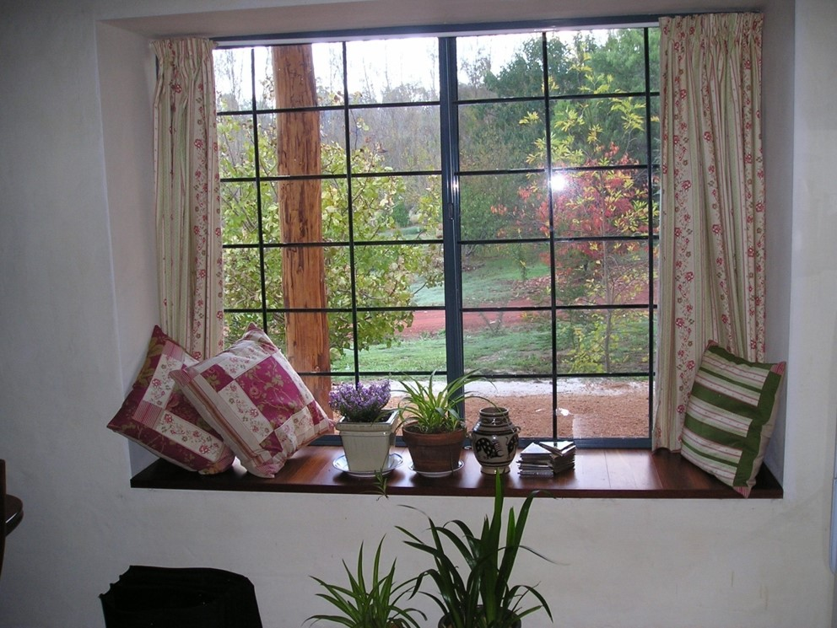
The wolf………..
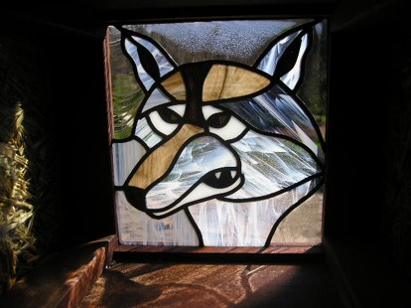
October 2008

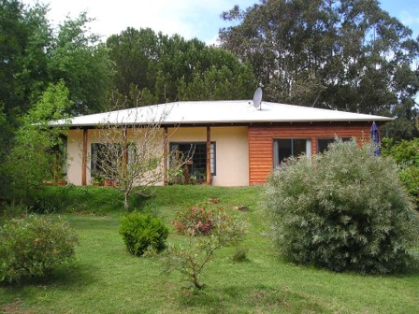

March 2023
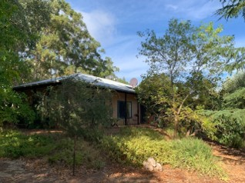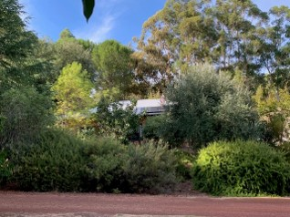
Final comments
- Should have had strata title by-laws in place at the very beginning.
- Don’t expect everyone to get on.
- $250 per quarter for maintenance.
- One meeting per year.

